**ADVANCED RESULTS RETRIEVAL SYSTEM.**

***An industry oriented mini project report submitted***

***In partial fulfillment of the requirement for the award of the degree of***

**BACHELOR OF TECHNOLOGY**

in

**COMPUTER SCIENCE AND ENGINEERING**

*by*

**D. NARENDRA REDDY (15131A0553)**

**CH. SAI MANIROOP (15131A0549)**

**D.MANOJ KUMAR (15131A0550)**

**CH. NARENDRA (15131A0537)**

*Under the esteemed guidance of*

**Mr. P. ARAVIND**

**Associate professor**



**DEPARTMENT OF COMPUTER SCIENCE AND ENGINEERING**

GAYATRI VIDYA PARISHAD COLLEGE OF ENGINEERING(A)

(AFFILIATED TO JNTU, KAKINADA, AP)

VISAKHAPATNAM – 530048

2015 – 2019



**DEPARTMENT OF COMPUTER SCIENCE AND ENGINEERING**

GAYATRI VIDYA PARISHAD COLLEGE OF ENGINEERING(A)

(AFFILIATED TO JNTU, KAKINADA, AP)

VISAKHAPATNAM – 530048

**CERTIFICATE**

This is to certify that the project work entitled “**ADVANCED RESULTS RETRIEVAL SYSTEM**” being submitted D. NARENDRA REDDY (15131A0553), CH.SAI MANIROOP (15131A0549), D.MANOJ KUMAR(15131A0550), CH.NARENDRA (15131A0537) in partial fulfillment of the requirement the award of the degree of “Bachelor of technology” in Computer Science and Engineering is a record of bonafide work done by them under my supervision during the academic year 2016.

**Internal guide Head of the Department**

**Mr.P. Aravind Dr.P. Krishna Subba Rao**

**Associate professor Professor**

**Department of CSE Head of Department CSE**

**GVPCOE(A). GVPCOE(A)**.

**DECLARATION**

We hereby declare that this is dissertation of our own work except where specifically ask to the contrary and it is not substantially the same as any dissertation which has been submitted to any university.

**By**

**D. NARENDRA REDDY (15131A0553)**

**CH. SAI MANIROOP(15131A0549)**

**D.MANOJ KUMAR(15131A0550)**

**CH. NARENDRA(15131A0537)**

**ACKNOWLEDGEMENT**

We thank **Prof. A.B.K.Rao** principal, **Gayatri Vidya Parishad College of Engineering(A)**  for extending his utmost support and cooperation in providing all the provisions for the successful completion of the project.

We consider it our privilege to express our deepest gratitude to **Dr.P.K.Subba Rao** Professor, Head of the Department, Computer Science and Engineering, for his valuable suggestions and constant motivation that greatly helped the project work to get successfully completed.

We thank Mr.P.Aravind sir for providing constant support and guidance throughout and helped in completing the project successfully.

We also thank all the members of the staff in Computer Science Engineering for their sustained help in our pursuits.

We thank all those who contributed directly or indirectly in successfully carrying out his work.

**By,**

**D.NARENDRAREDDY(15131A0553)**

**CH. SAI MANIROOP (15131A0549)**

**D.MANOJ KUMAR (15131A0550)**

**CH. NARENDRA(15131A0537)**

ADVANCED RESULTS RETRIEVAL SYSTEM FOR GVPCE(A)

Abstract

**ABSTRACT**

Viewing results from a website has been the hardest part until now because of the tangled URLs. In the existing system, we may get results only for particular semester. In this proposed system, we can get results of all the semesters at once that are completed until now. This results retrieval application uses advanced web scraping techniques to extract the results from college website URLs that have been released till now. This system analyses the student ID say roll no. and displays the results based on his preferences like Regular or Supplementary or both. Moreover, this system facilitates the outsiders to conveniently view the results of any student and it is used for the personal assessment based on the obtained result. In this project, Graphical User interface will be provided using Web App to ensure the best experience for user. The web app is made 24x7 available to the users. The users of this web app need to have active internet connection for the retrieval of results.

Index

**INDEX**

page no.

1. ABOUT THE PROJECT…………………………………………............... 12

2. PROJECT SCOPE………………………………………………… …….. 13

2.1 EXISTING SYSTEM……………………………………………… 14

2.2 PROBLEMS IN EXISTING SYSTEM…………………………… 14

2.3 PROPOSED SYSYTEM…………………………………………… 14

3. FEASIBILTY REPORT………………………………………………….. 15

3.1 TECHNICAL DESCRIPTION…………………………………….. 16

3.2 REQUIRED HARDWARE…………………………………………. 16

3.3 REQUIRED SOFTWARE…………………………………………. 16

3.4 FEASIBILITY TYPES…………………………………………….. 17

4. ANALYSIS……………………………………………………………….. 18

4.1 SRS DOCUMENT…………………………………………………. 19

4.2 SCOPE OF DEVELOPMENT……………………………………… 20

4.3 ABOUT PYTHON…………………………………………………. 20

5. DESIGN…………………………………………………………………… 21

5.1 UML SPECIFICATIONS……………………………………………… 22

5.2.USE CASES…………………………………………………………..... 23

5.3 SEQUENCE DIAGRAM………………………………………… 24

5.4 CLASS DIAGRAM………………………………………………… 24

5.5 ACTIVITY DIAGRAM……………………………………………. 25

6. CODING………………………………………………………………… 26

6.1 SAMPLE CODE………………………………………………….….. 27

6.2 OUTPUT SCREENS………………………………………………… 34

7. TESTING………………………………………………………………. 40

7.1 LEVELS OF TESTING……………………………………………… 41

8. CONCLUSION………………………………………………………… 43

9. BIBLIOGRAPHY ……………………………………………………… 45

9.1 REFERENCES……………………………………………………… 46

9.2 LIST OF WEBSITES………………………………………………… 46

**List of figures :**

Fig:5.1 Usecase diagrams………………………………………………….. 23

Fig:5.2 Sequence diagrams…………………………………………… …... 24

Fig:5.3 Class diagrams……………………………………………………… 24

**List of Screenshots:**

Screenshot.6.1-directory structure…………………………………………… 27

Screenshot:6.2 Displaying html page……………………………………….. 35

Screenshot:6.3 Entering Student details……………………………………… 36

Screenshot:6.4:displaying student.html in the browser………………………. 39

About The Project

1. **ABOUT THE PROJECT**

In the contemporary world, education plays a major role. By which one believes that with education we can do anything we want. So, there are many private and public institutions for educating students. In this education system, the skill of any individual is assessed based on his/her performance in various aspects. In this digital era, all the results and updates within the institution are maintained through their official websites. With the help of college website, all the students and Faculty will be able to know each and every updates and news regarding any semester results, new time tables. The teachers, parents and students can know the placements of the students in any college through their official website.

But in some college websites like GVPCE, the retrieval of semesters results is not so good. Anyway students will be able to find their results of latest semester at ease. As the parents are not so aware of all the details of their wards current study, it becomes quite difficult to know their wards results. The difficulty here is we can get the results only for particular semester. If we want to know or check the previous results of any student it is the hardest part because of the tangled urls and they need to remember the dates of the commencement of results. In order to avoid these type of problems on behalf of students, parents and faculty, we ourselves have learnt some advance concepts of python programming language and devised a web app which gives results of all the semesters at once that are completed until now. The so called Advanced results retrieval system facilitates anyone to conveniently view the results of any student and it is used for the personal assessment based on the obtained result. This system analyses the student ID say roll no. and displays the results based on his preferences like Regular or Supplementary. This webapp is dynamic and in such a way that there is no supporting software required in order to store new and fresh links from the college website. Soon after a new link arrives in the website this webapp grabs them. This web app is done without the college database access. So, we can make use of this Webapp for different colleges.

Project Scope

**2. PROJECT SCOPE**

**2.1 Existing System:**

As mentioned earlier, in the existing system, the retrieval of the semester results is not that much easy. Whether we want to obtain the Regular or Supplementary or Revaluation results we shall remember the result urls and their specific dates. Anyway after struggling a lot ,we’ll be able to obtain the results.

**2.2. Problems in Existing system:**

1)If we want to obtain the results of previous semesters, we need to remember all their dates and then view the results of each semester in separate html pages.

2)Generally many college websites do not provide a way to obtain all the results of all the semesters at once that are completed until now.

These are some of the problems faced by the students, parents, faculty members. So, hereby we proposed a new system to obtain all the results at a single instance.

**2.3. Proposed System: -**

In the proposed system, by simply providing the student regd no. and some queries anyone can obtain the results of all the semesters at a time. Moreover, parents can easily access the results of their wards as parents are aware of only their child’s roll no. There is more scope for adding new features like SGPA or CGPA etc in this proposed system.

Feasibility Report

**3. Feasibility Report**

**3.1 Technical Description:**

**A Python program that can be deployed as a webapp using the Flask API.**

The web app is not directly connected to the college database instead it uses advanced web-crawling techniques to extract all the urls and then filter them as per our requirement and pulls the result data of the student from the database indirectly through website result links.

**3.2 REQUIRED HARDWARE:**

Minimum Hardware requirements

* Processor (CPU : Intel core i3(1.8 Ghz)or more/AMD A8(1.9 Ghz).
* Memory(RAM) : Min 1GB
* Storage(Hard disk) : Min 500GB
* Active Wifi 802.11 ac/b/g/n or Ethernet Connection.

**3.3 REQUIRED SOFTWARE:**

Minimum Software requirements:

* Operating system : Ubuntu 14.04 or above / windows 7 and above
* Language : Python-2.7
* IDE : PyCharm,Atom,Jupyter notebook.
* DEPENDENCIES : Beautiful Soup, mechanize, requests, pandas, numpy etc.,
* BROWSER : Mozilla Firefox/Microsoft Edge/Google Chrome.
* WEB FRAMEWORK : Flask using Python.

**3.4 FEASIBILITY TYPES:**

**Technical feasibility:**

The technical issue usually raised during the feasibility stage of the investigation includes the following:

* Does the necessary technology exist to do what is suggested?
* Do the proposed equipment’s have the technical capacity to hold the data required to use the new system?
* Will the proposed system provide adequate response to inquiries, regardless of the number or location of users?
* Can the system be upgraded if developed?
* Are there technical guarantees of accuracy, reliability, ease of access and data security?

YES, proposed system is cost efficient and time efficient once implemented on a particular type of data it can be reused many times.

**Financial Feasibility:**

The system as a whole sees a very highly integrated time saving construct and is compatible with any device through web. The application can be later deployed as a website which can be accessible throughout the world by investing some money. Not only students, every individual will be above to access this webapp through the launched website.

Analysis

Report

**4. ANALYSIS Report**

**4.1 SRS DOCUMENT**

**Intended Audience and Reading Suggestions**

The document is prepared keeping is view of the academic constructs of my Bachelor’s Degree from university as partial fulfillment of my academic purpose the document specifies the general procedure that that has been followed by me, while the system was studied and developed. The general document was provided by the industry as a reference guide to understand my responsibilities in developing the system, with respect to the requirements that have been pin pointed to get the exact structure of the system as stated by the actual client.

The system as stated by my project leader the actual standards of the specification were desired by conducting a series of interviews and questionnaires. The collected information was organized to form the specification document and then was modeled to suite the standards of the system as intended.

**Document Conventions:**

The overall documents for this project use the recognized modeling standards at the software industries level.

* + The Physical dispense, which state the overall data search for the relational key whereas a transaction is implemented on the wear entities.
  + Unified modeling language concepts to give a generalized blue print for the overall system.
  + The standards of flow charts at the required states that are the functionality of the operations need more concentration.

**4.2 SCOPE OF DEVELOPMENT**

**Future scope:**

• In the near future, it will be installed in flask api as a webapp and so it will be published in internet by deploying the webapp in python anywhere or heroku.

• The URLs will be updated continuously and it will make online access to the users up to date. As a result, it can be sensitively satisfying current user tastes based on the query he entered.

• There is large scope of development of this webapp because we can add many new features in this app.

• Moreover, we can also create an android app so that later it can be deployed in playstore.

* 1. **PYTHON:**
* Easy to code
* Python is a High- Level Language
* Python is an Interpreted Language
* Python can be used for GUI Programming
* Python Language is Object-Oriented
* It is Free and Open-Source
* Python Is Portable
* It had Large Standard Library
* Python can be used for GUI Programming
* Python is Extensible
* **The only efficient language the supports web-crawling with popular packages like Scrapy and Beautifulsoup.**

Design

Document

**5. Design Document**

**5.1 Unified Modeling Language Specifications**

**User Model View:** The UML user model view encompasses the models which define a solution to a problem as understood by the client or stakeholders. This view is often also referred to as the Use Case or scenario view. The main UML model encompassed by this view is the:

**Structural model view:**  Capture static aspects or structure of a system. Structural Diagrams include: Component Diagrams, Object Diagrams, Class Diagrams and Deployment Diagrams.

**Behavioral Model View:** Capture dynamic aspects or behavior of the system. Behavior diagrams include: Use Case Diagrams, State Diagrams, Activity Diagrams and Interaction Diagrams.

**Implementation Model View:** The UML Implementation View combines the structural and behavioral dimensions of the solution realization or implementation. The view is often also referred to as the component or development view.

**Environmental Model View:** These UML models describe both structural and behavioral dimensions of the domain or environment in which the solution is implemented. This view is often also referred to as the deployment or physical view.

**UML:**

**Unified Modelling Language (UML)** is a general purpose modelling language. The main aim of UML is defining a standard way to **visualize** the way a system has been designed. It is quite similar to blueprints used in other fields of engineering.

UML is **not a programming language**; it is rather a visual language. We use UML diagrams to portray the **behaviour and structure** of a system. UML helps software engineers, businessmen and system architects with modelling, design and analysis. The Object Management Group (OMG) adopted Unified Modelling Language as a standard in 1997. It’s been managed by OMG ever since. International Organization for Standardization (ISO) published UML as an approved standard in 2005. UML has been revised over the years and is reviewed periodically. Software development is a similar process in many ways. UML has emerged as the software blueprint methodology for the business and system analysis, designers, programmers and everyone involved in creating and deploying the software system in an enterprise. The UML provides for everyone involved in software development process the vocabulary to communicate about software design.

**5.2.USE CASE DIAGRAM:**

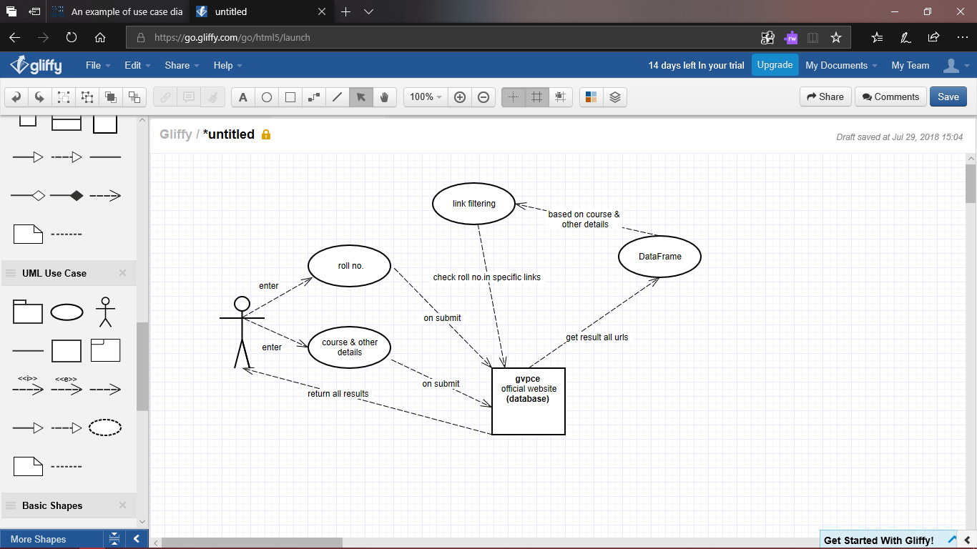

**FIG.5.1: Use Case Diagram for Retrieval of all the results**

**5.3. SEQUENCE DIAGRAM:**

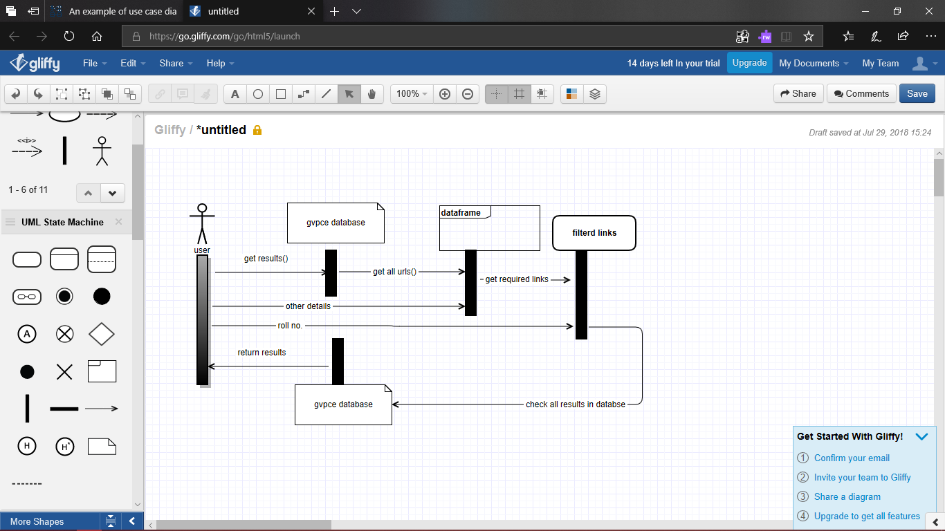

**FIG.5.2: Sequence Diagram for Retrieval of all the results**

**5.4 CLASS DIARAM:**

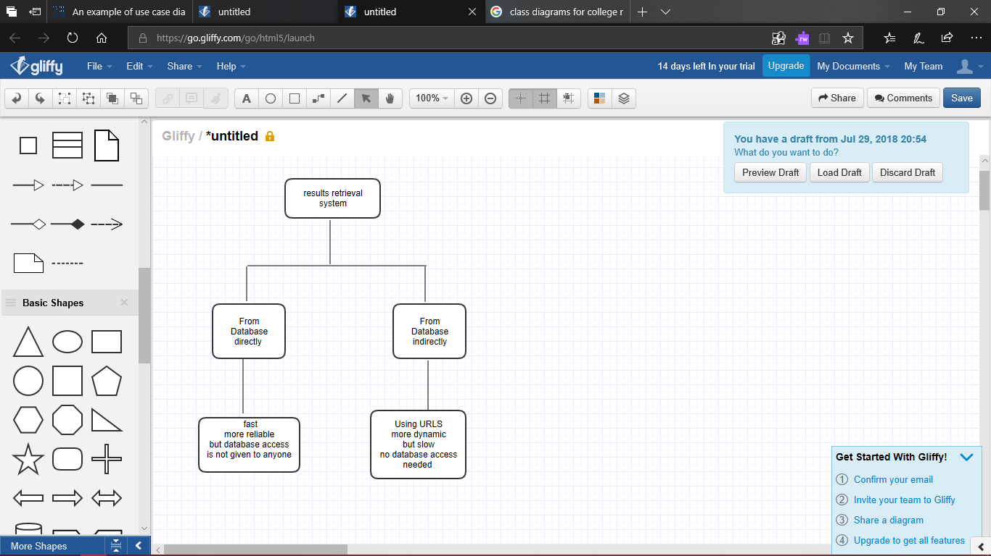

**FIG.5.3: Class Diagram for Retrieval of all the results**

**5.5 ACTIVITY DIAGRAM:**

**ALGORITHM:**

Step-1:First store all the urls of results and the corresponding title in a dataframe

Step-2:Filter all the links in the dataframe depending on the queries we choose.

Step-3:Only few urls are left in which we want to check all the results.

Step-4:We should enter the roll no.,then all the results in each filter urls gets concatenated to other and then the final result is displayed

Step-5:Thus all the completed results of the student are displayed at a single instances.

Step-6:Finally the web app is deployed in pythonanywhere or heroku.

Coding

**6. CODING**

This is the most important phase of the project.

**6.1:SAMPLE CODES:**

**Directory Structure:**

Project----->flask----->flaskr

|

|---->static---->banner.jpg

|

|---->templates----->student.html

| |------>results.html

|----->second.py

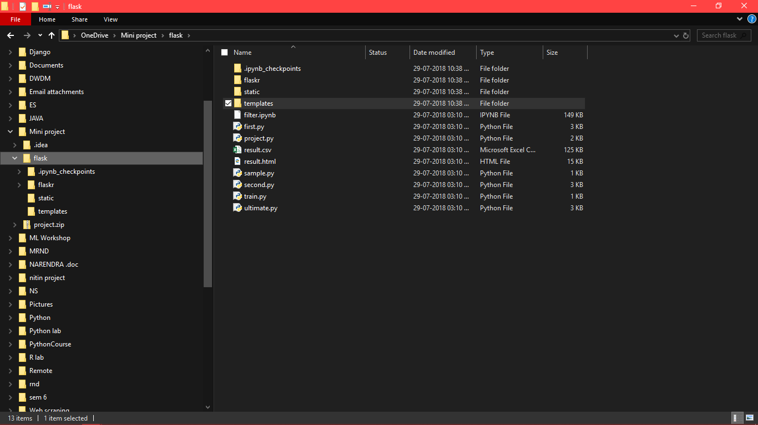

**Screenshot.6.1-directory structure**

**flask_app.py**

from flask import Flask, render_template, request

import mechanize

from bs4 import BeautifulSoup

import urllib2

import re

import pandas as pd

import numpy as np

import matplotlib.pyplot as plt

app = Flask(__name__)

@app.route('/')

def student():

return render_template('student.html')

@app.route('/result',methods = ['POST', 'GET'])

def result():

if request.method == 'POST':

rolls = request.form.get("Name")

a=request.form.get("course")

b=request.form.get("other")

a=str(a)

b=str(b)

if(b=="Supple+Regular"):

b="Regular"

c="Supplementary"

else:

c="-1"

start="http://gvpce.ac.in"

l1=[]

html_page = urllib2.urlopen("http://gvpce.ac.in/result.html")

soup = BeautifulSoup(html_page)

for link in soup.findAll('a'):

l1.append(start+str(link.get('href'))[2:])

links=[]

for i in range(len(l1)):

l=" "

for j in l1[i]:

if(j==' '):

l=l+'%20'

else:

l=l+j

links.append(l)

text=[]

for i in soup.findAll('a'):

text.append(str(i.text).lstrip('\n'))

#links.append(str(link.find('font'))[22:])

urls=np.asarray(links[8:])

name=np.asarray(text[8:])

df1=pd.DataFrame(name,columns=['name'])

df2=pd.DataFrame(urls,columns=['urls'])

result = pd.concat([df1,df2],axis=1)

s=["""<center><div class="header" style="width: 1003px; height: 130px">

<h1>

<img src="static/banner.jpg" width="1000" height="100" border="0"></h1>

<div class="subheader_left" style="width: 1000px; height: 24px">

&nbsp;</div>

</div><center>"""]

for i in range(500):

if((a in result.name[i]) and (b in result.name[i] or c in result.name[i]) and ("(R-2015)" in result.name[i])):

br = mechanize.Browser()

br.open(result.urls[i])

br.select_form(nr=0)

br.form['u_input']=rolls

br.submit()

soup = BeautifulSoup(br.response().read(),"html5lib")

if (soup.findAll('table')) :

#print(soup("td",{'colspan':'4'})[2].text)

s.append("<center>")

s.append(soup.find('font'))

s.append(soup.find('table'))

s.append("</center>")

s.append("<br><br><br>")

else:

i+=1

br.close()

with open("templates/result.html", "w") as f:

for i in s:

f.write(str(i)+'\n')

return render_template("result.html")

if __name__ == '__main__':

app.run(debug = True)

**Student.html:**

<html>

<body>

<form action = "<http://localhost:5000/result>" method = "POST">

<center> <div class="header" style="width: 1003px; height: 130px">

<h1>

<img src="{{url_for('static', filename='banner.jpg')}}" /><br>

</h1><br><br>

<div><b>Roll No: </b><input type = "text" name = "Name" placeholder="enter your complete roll no" /></div><br>

<div ><b>Course:</b>

<div> <input type="radio" name="course" value="B.Tech" checked> B.Tech<br>

<input type="radio" name="course"se value="M.Tech"> M.Tech<br>

<input type="radio" name="course" value="M.C.A"> M.C.A<br></div>

</div><br>

<div><b>Other Details:</b>

<div> <input type="radio" name="other" value="Regular" checked>Regular <br>

<input type="radio" name="other" value="Supplementary"> Supple<br>

<input type="radio" name="other" value="Supple+Regular"> Supple+Regular<br></div>

</div><br>

<div><p><input type = "submit" value = "submit" /></p></div>

</center>

</form>

</body>

</html>

**result.html**

This is the output file where the results of a student are displayed.

**6.2: OUTPUT SCREENS:**

**STEPS OF EXECUTION:**

**1)Running the second.py in terminal**

Running server: 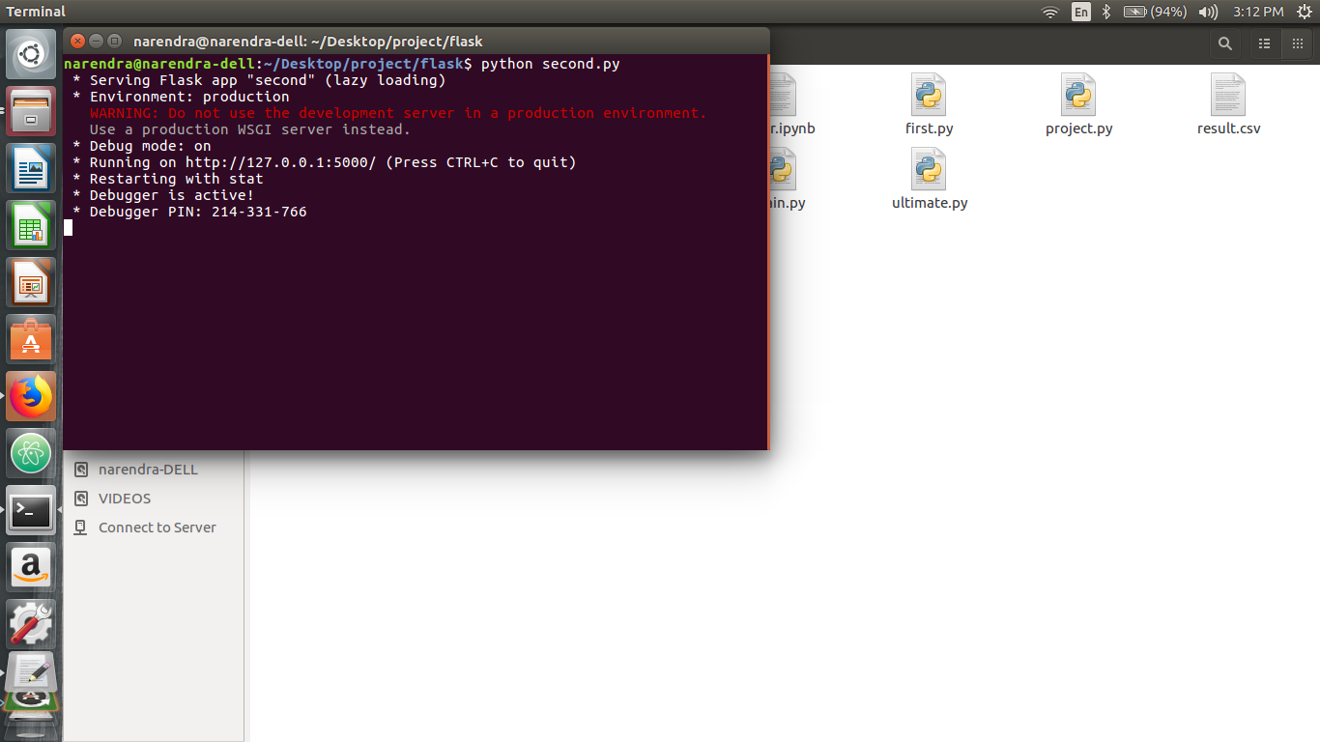

Screenshot:6.1:Running the program

2)The second.py calls student.html to be loaded in the browser:

**Student.html gets executed in the local server:**

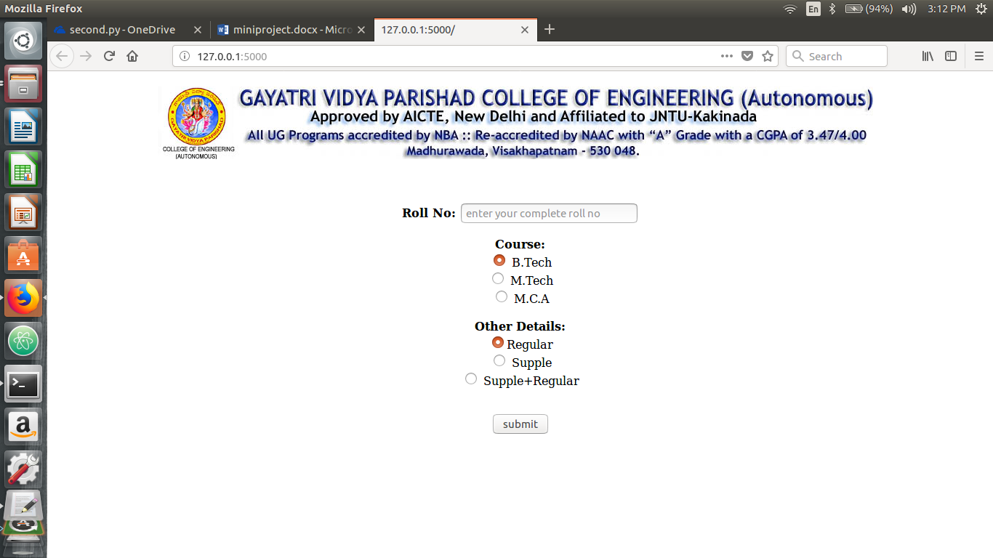

Screenshot:6.2:displaying student.html in the browser

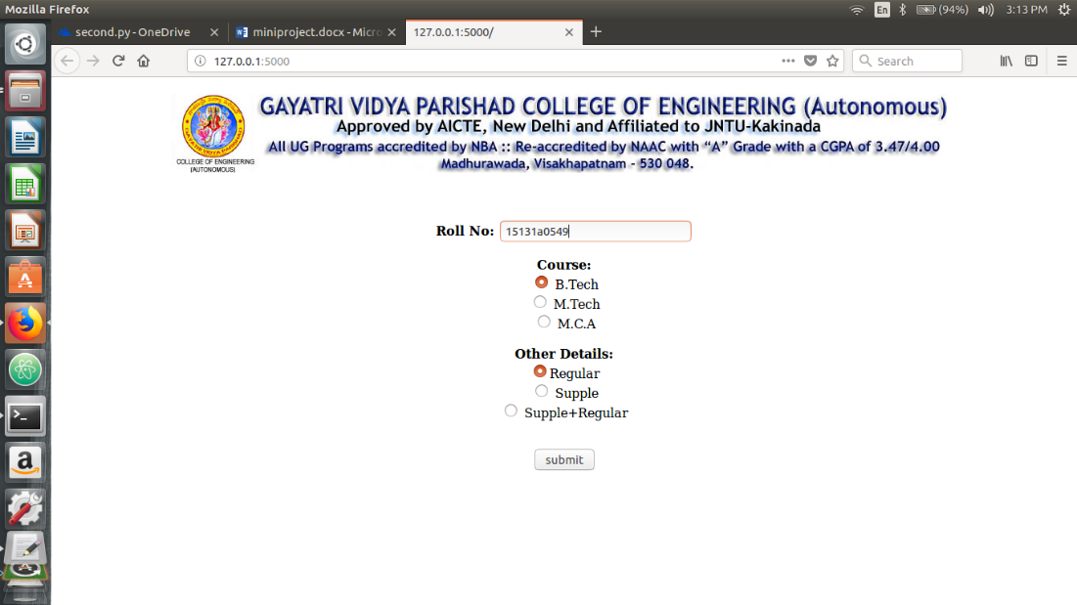**3)User enters the desired roll no and radio buttons as follows:**

Screenshot:6.3:entering details in student.html in the browser

**4)After submitting , The local server is redirected to the results page as follows:Result.html**

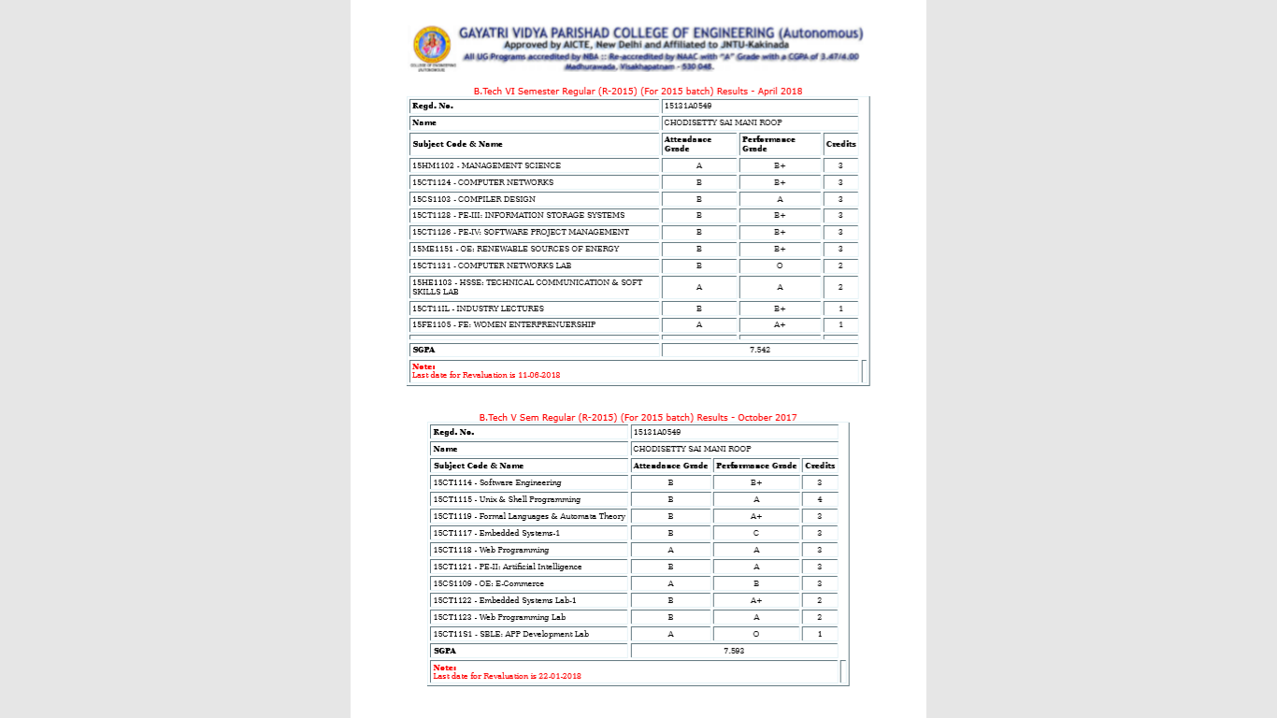

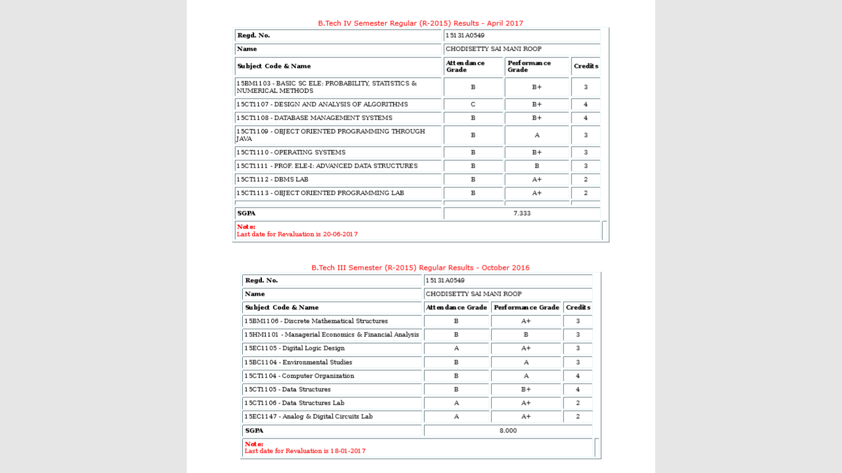

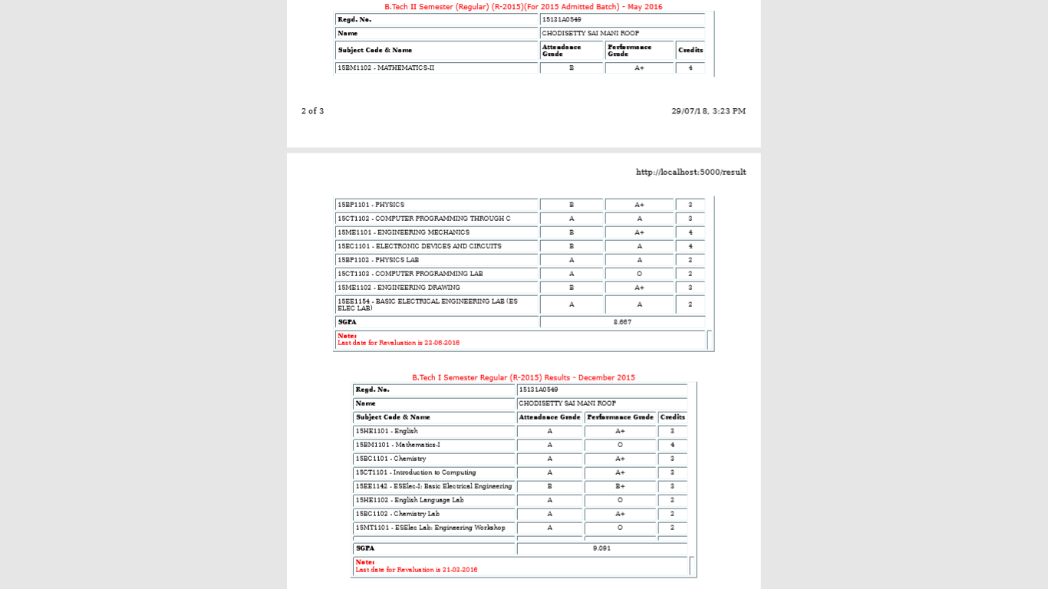

Screenshot:6.4:displaying student.html in the browser

In this we can get the results of all semesters based on the query selected by the user.

Testing

**7. TESTING**

**Testing:**

Testing is the process of detecting errors. Testing performs a very critical role for quality assurance for ensuring the reliability of software. The result of testing are used later on during maintenance also.

Purpose of Testing:

The aim of testing is often to demonstrate that a program works by by showing that it has no errors. The basic purpose of testing phase is detect the errors that maybe be present in the program. Hence one should not start testing with the intent of showing that a program- works, but the intent should be to show that a program does’t work.

Testing Objectives :

The main objective of testing is to uncover a host of errors, systematically and with minimum effort and time. Stating formally, we say, testing is a process of executing a program with the intent of finding of an error. A successful test is one that uncovers an as at undiscovered error. A good test case is one that has a high probability of finding error, if it exists. The software more or less confirms to be quality and reliable standards

**7.1 Levels of Testing**

In order to uncover the errors present in different phases we have the concept of levels of testing. The basic levels of testing are as shown below…

Unit Testing:-

The philosophy is behind testing is to find errors. Test cases are devised with this in mind. A strategy employed for system testing is code testing.

Code Testing:-

This strategy examines the logic of the program. To follow this method we develop some test data that resulted in executing every instruction in the program and module i.e., every path is tested. Systems are not designed as entire nor or they tested as single systems. To ensure that the coding is perfect two types of testing is performed or for that matter is performed on all systems.

White Box Testing:-

This unit is a testing method where a unit will be taken at a time and tested thoroughly at a statement level to find the maximum possible errors. I tested step wise every piece of code, taking care that every statement in the code is executed at least once . The white box testing is also called glass box testing.

Black Box Testing:-

This testing method considers a module as a single unit and checks the unit at interface and communication with other modules rather than getting in to details at statement level. Here the module will be treated as black box that will take some input and generate output. Output for a given set of input combinations are forwarded to other modules.

CONCLUSION

**8.CONCLUSION**

Hereby we can conclude that student life begins easy by using this web app. In this digital world, the technology is updating every second, so with the help of advanced technologies we can make our life a cake walk. And learning is a never ending process. Now –a –days python programming language is developing and evolving in a very fast pace which paved a way to complete this mini project successfully.

BIBLIOGRAPHY

**9. BIBLIOGRAPHY**

**9.1 REFERENCES:**

[**https://www.gvpce.ac.in/**](https://www.gvpce.ac.in/)

[**http://gvpce.ac.in/result.html**](http://gvpce.ac.in/result.html)

**9.2 LIST OF WEBSITES:**

<https://docs.python.org/3/>

<https://www.crummy.com/software/BeautifulSoup/>

<http://flask.pocoo.org/>

<https://www.pythonforbeginners.com/mechanize/browsing-in-python-with-mechanize/>

https://docs.python-requests.org/en/master/https://github.com/jupyterlab/jupyterlab/

<https://www.python.org/>